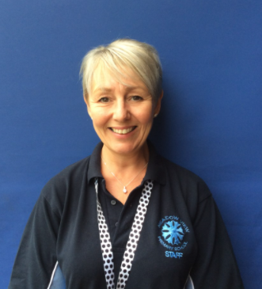
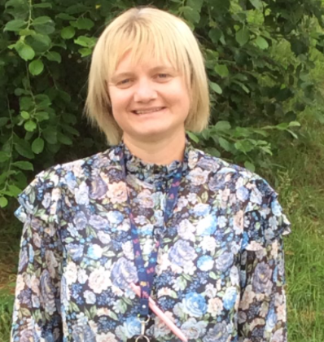
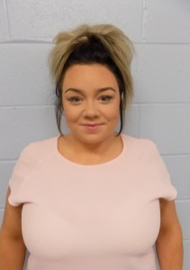
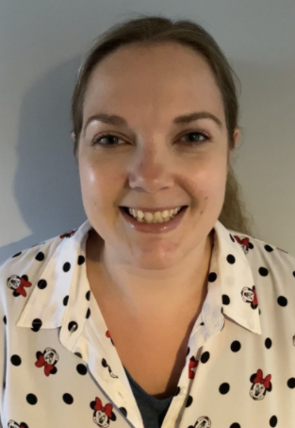
Year 3/4 Kingfishers
Miss Hunter
Teacher
Miss Weyman
Teaching Assistant
Mrs Coult
Teaching Assistant
Mrs Foster
Teaching Assistant

Dear children,

Welcome to class 3/4! I am really looking forward to being your class teacher next year. Our class name will be the Kingfishes!
As support in Year 3 and 4 we will have Mrs Foster. She is really looking forward to working with us. She feels very lucky to be supporting you in class with your learning, new experiences and challenges. Mrs Foster has worked at Meadow View for over 20 years and finds her job incredibly rewarding.
Mrs Coult will be working in Year 3 and 4 too! My name is Mrs Coult and I am a teaching assistant. I enjoy reading and spending time with my family. I am really excited about starting the new school year working in Yr3/4.
I am Miss Weyman, I have a 5-year-old daughter and my favourite colour is pink. I love to watch Disney movies and horse riding with my daughter.
I can’t wait to have lots of learning fun in Y3/4.

My name is Miss Hunter. In September, I will have been a teacher at Meadow View for 12 years! I love teaching and helping children to believe in themselves and I will support you to achieve your potential. I am the SENCO in school so I help and support lots of children across school. I also lead on Maths and modern foreign languages.

I have a cat called Harvey, who is 12. He is very adventurous and likes to get up to mischief.

I love acting. I am part of an amateur dramatics group, where we perform a pantomime each year. I have played a range of roles from a Princess, to a Prince to the evil Maleficent and Gothel!

Reading is something I really enjoy. Books are magical and they take you away to a new place and on new adventures! We will ensure we read every day to help us become excellent readers.

We are all looking forward to working with you next year, see you soon!

Miss Hunter and the Year 3/4 team

