Susan Gregg
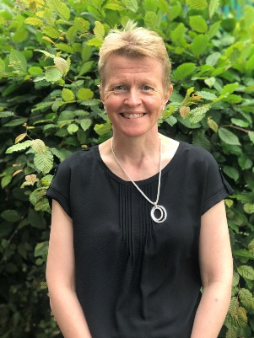
I am Susan Gregg and I act as staff Governor for Meadow View Primary. I am lucky to work as Assistant Head Teacher with responsibility for inclusion and EYFS at school. Meadow View School is a fantastic place for children to learn and for staff to teach, support and nurture children. Meadow View’s Governing Body works tirelessly to pursue the very best for children, parents, carers and the community and I very much enjoy being part of that. Outside of school I really enjoy gardening and trying my best to keep fit!

